

The Lone Gunman

STREET DATE: OCT. 25th
Started in 1992 in Los Angeles as a duo, through the mid nineties as a full band and then finally as a solo artist, the band IDAHO has had Jeff Martin as the sole thread through all of the incarnations. Known mostly for four-string guitars, low tempos, spectral feedback and production nuance, IDAHO has never bowed to the pressures of being commercial. For his trouble, IDAHO has remained the eternal underground band. By luck the band has attracted a devoted worldwide following. Idaho is like the secret club of indie music, and for this record you’ll need the code words….

About: The Lone Gunman
Jeff Martin of IDAHO has never been known to be a political animal. No, on the contrary, he’s a recluse.
He has practically made a career out of writing hyper personal songs of an inner life. Absent for now are the four-string guitars, they have been traded in for a Wurlitzer, an old Prophet 5 and a collection of pianos.

While the way he writes may not have changed, his personal landscape is shifting along with the worlds. Rigged elections, “Peak oil”, Nine Eleven, and wars on resource rich nations - it’s a lot to think about, much less for one guy just trying to make a record in his living room.
Martin emerges from behind this cinema screen of paranoia and distrust to put out a record filled with conspiratorial allusions, though, with a wink and a smile, and a polka.

Part songs, part soundtrack, Martin travels deeper into his film score sensibilities.
Occasionally “ambient rock”, it is mostly on these instrumental tracks that he draws inspiration from ideas surrounding "peak oil" or surveillance programs and CIA Renditions, but in an elegantly cartoonish way.

At times Jeff displays a playful early Eno-like absurdity such as When Sunday Comes or You Flew and at other times is just happy to be in the moment. But it’s a life set against a background of darker flavors on other tracks like Live today again and The Mystery.

As one listener put it: “it’s the musical equivalent to the denouement of a political film thriller.”

With The Lone Gunman, Martin shows his unique talent for a timeless somber beauty.
- A.P. Renick
The Lone Gunman is Idaho’s 10th full-length release.
Mastered by Greg Calbi at Sterling Sound NYC

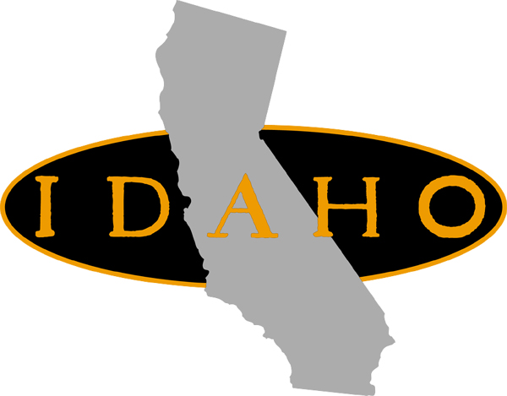™

Jeff Martin has been chosen as the composer for NBC’s new show “Inconceivable” airing this fall Fridays at 10:00PM
For interview requests, please contact John K Berry: john@retrophonic.com
More biographical information can be found at: http://www.slidingpast.com

